**Xampp installation process**:

First of all download the xampp installation file from official website

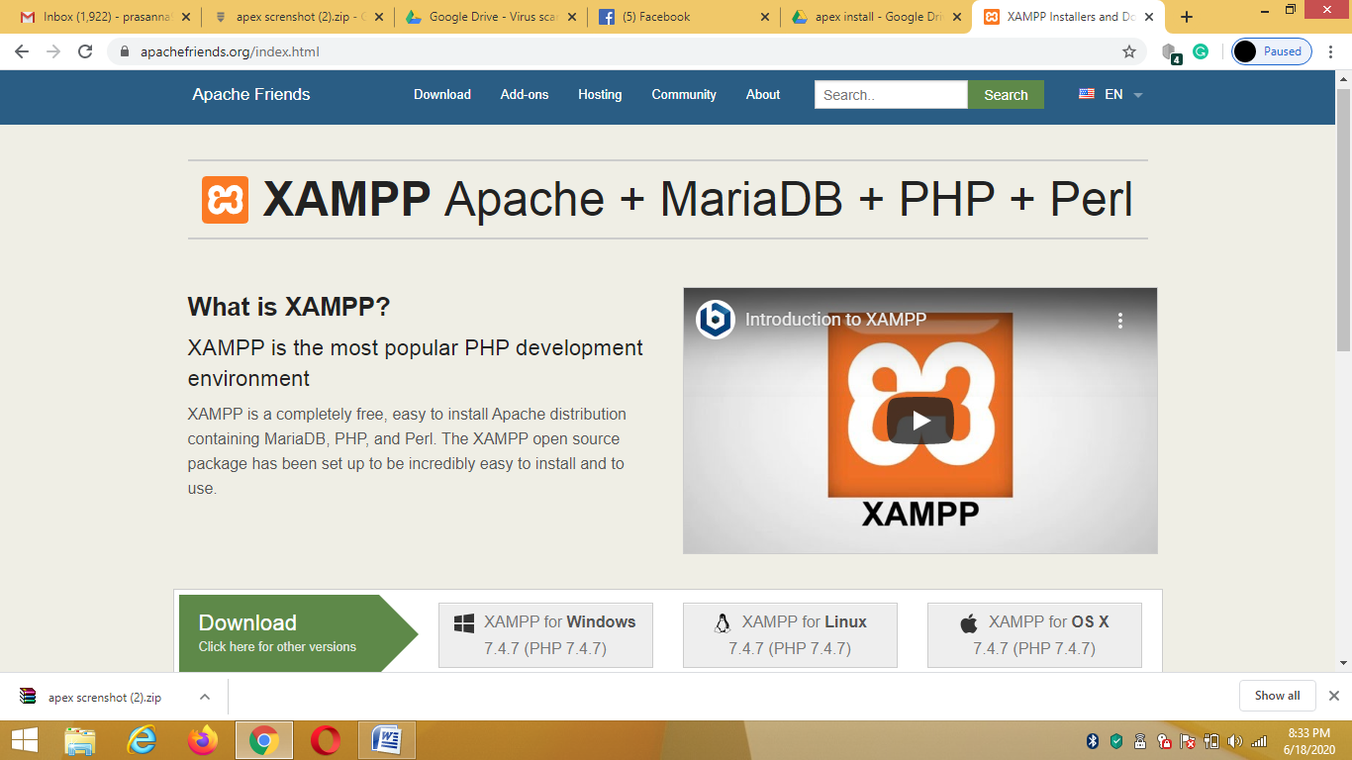

step 1: Open the downloaded file and click yes

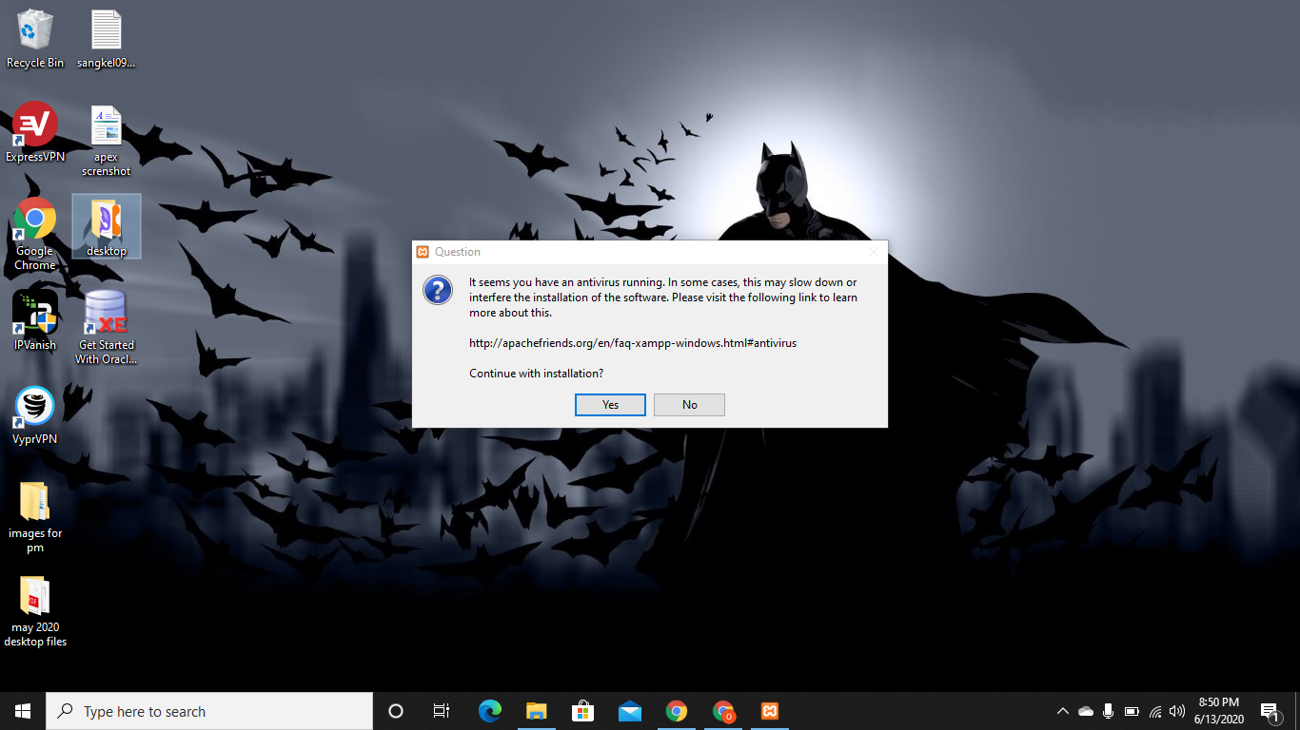

Step 2: Click Next

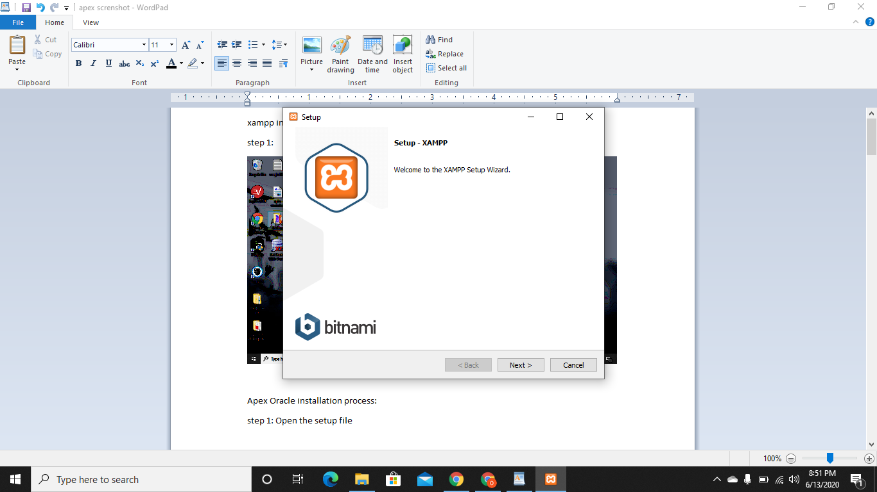

Step 3: Select all the options and click next

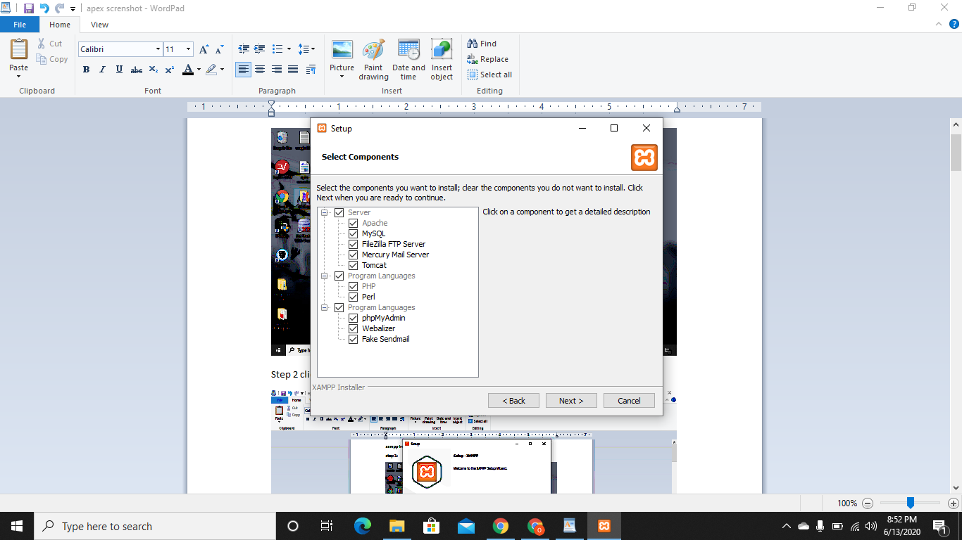

Step 4: Select the directory to install the software

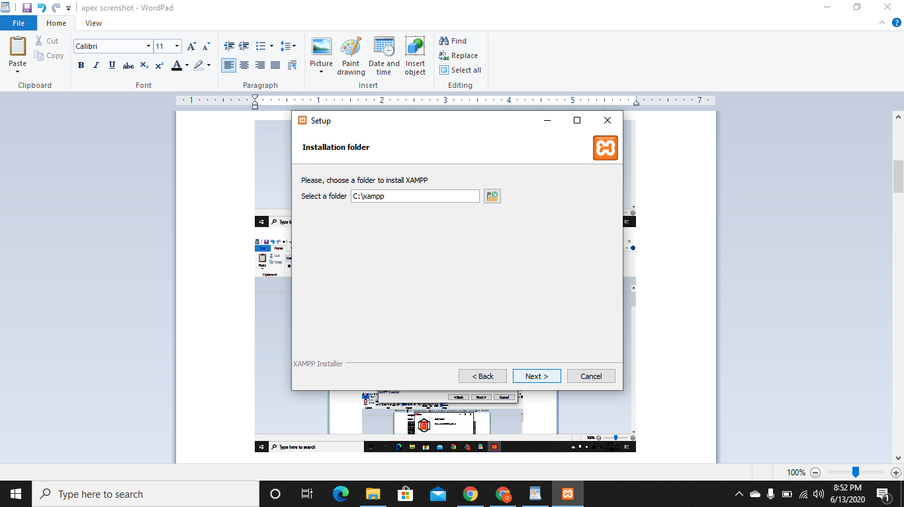

Step 5: Click on Next

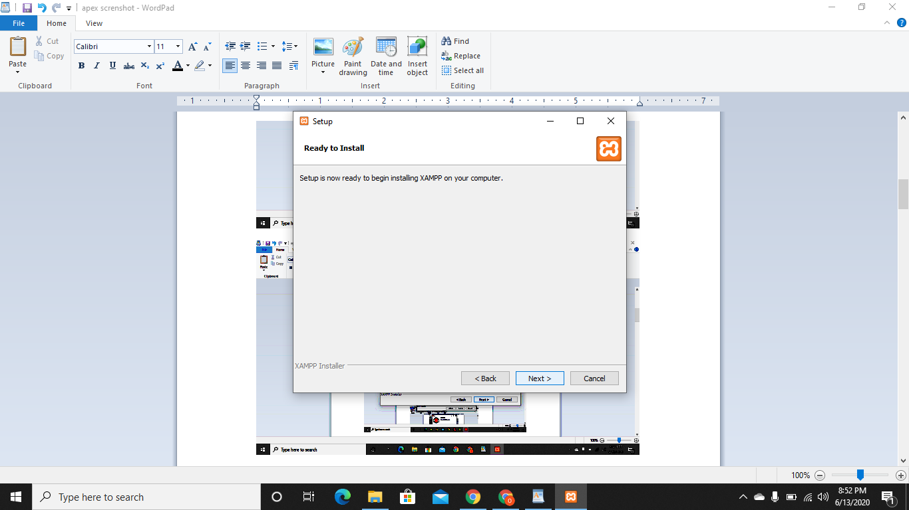

Step 6: Wait for the completion of installation

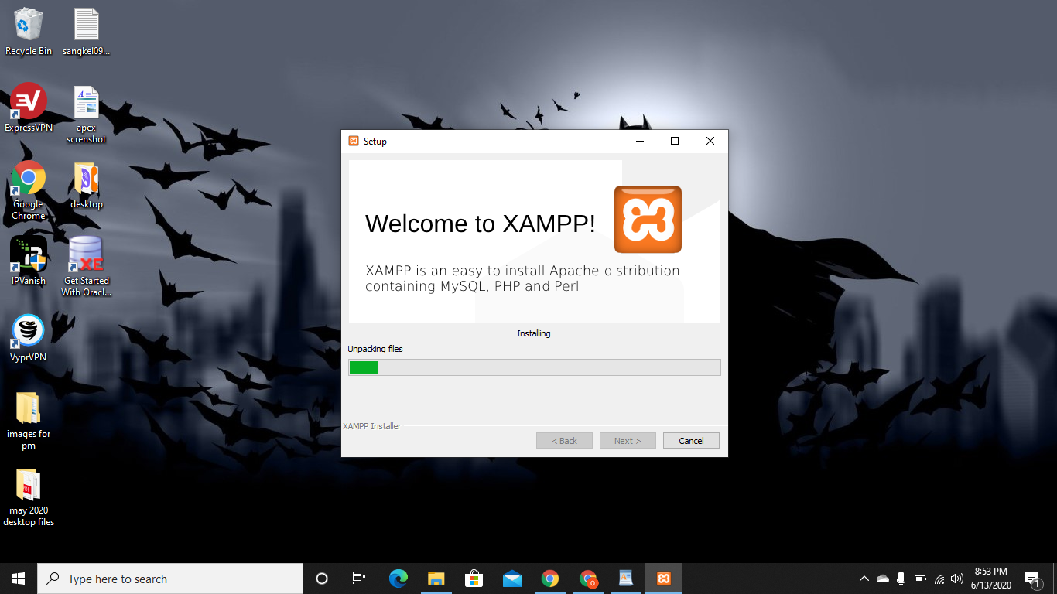

Step 7: After the completion, click on finish

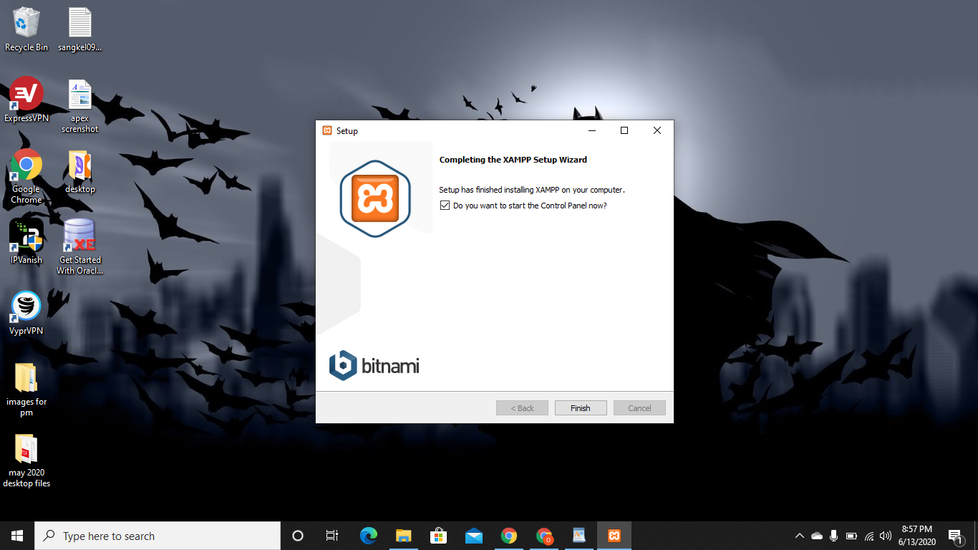

Step 8:Choose the suitable language

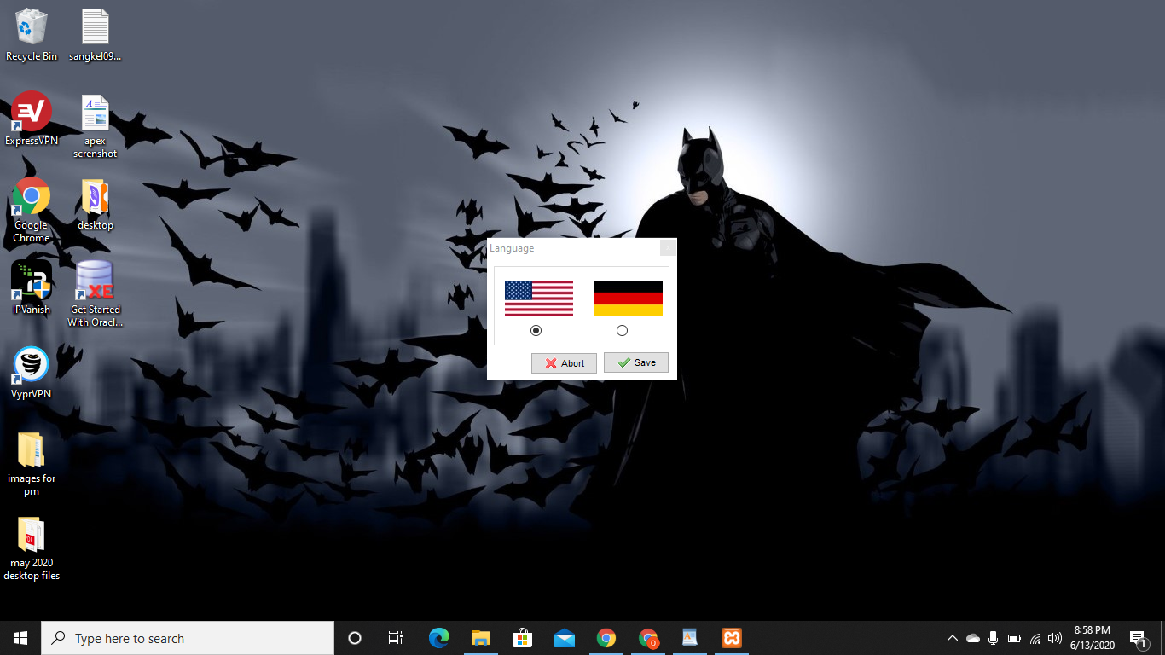

Step 9: Click on start for required settings:

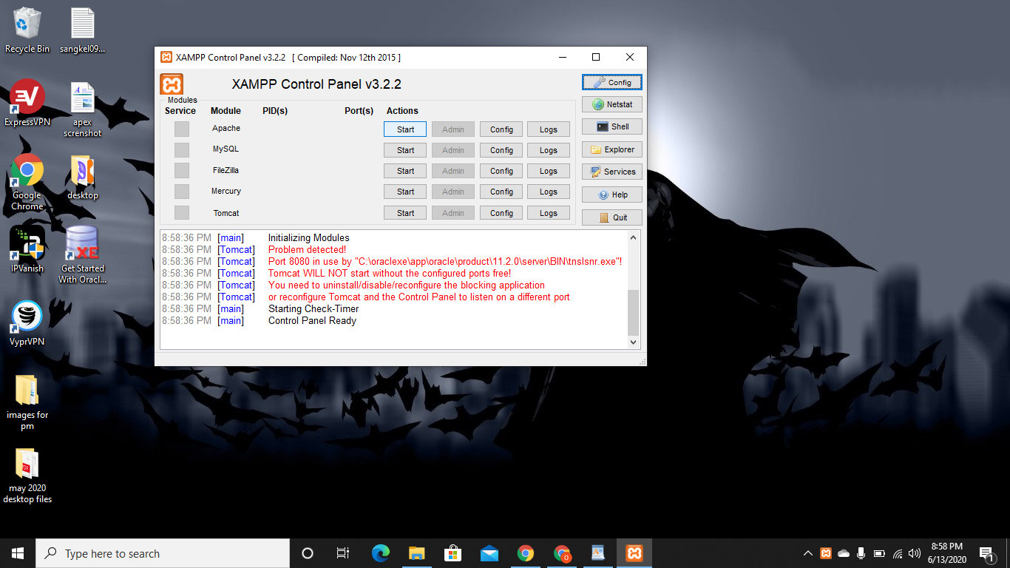

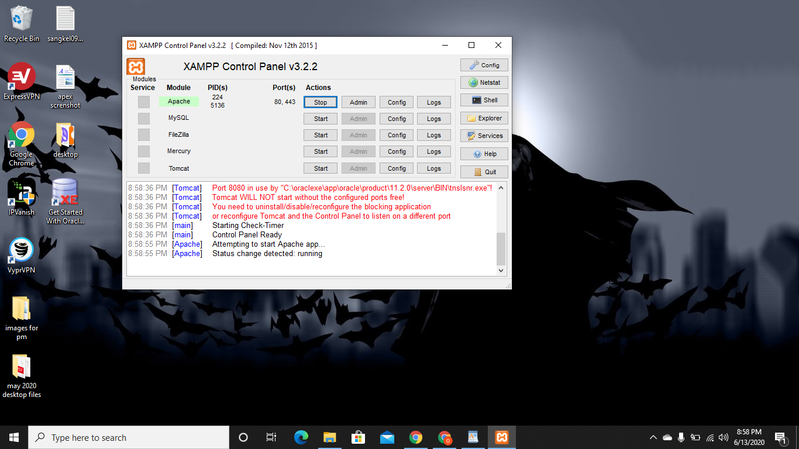

**Apex Oracle installation process:**

step 1: Open the setup file

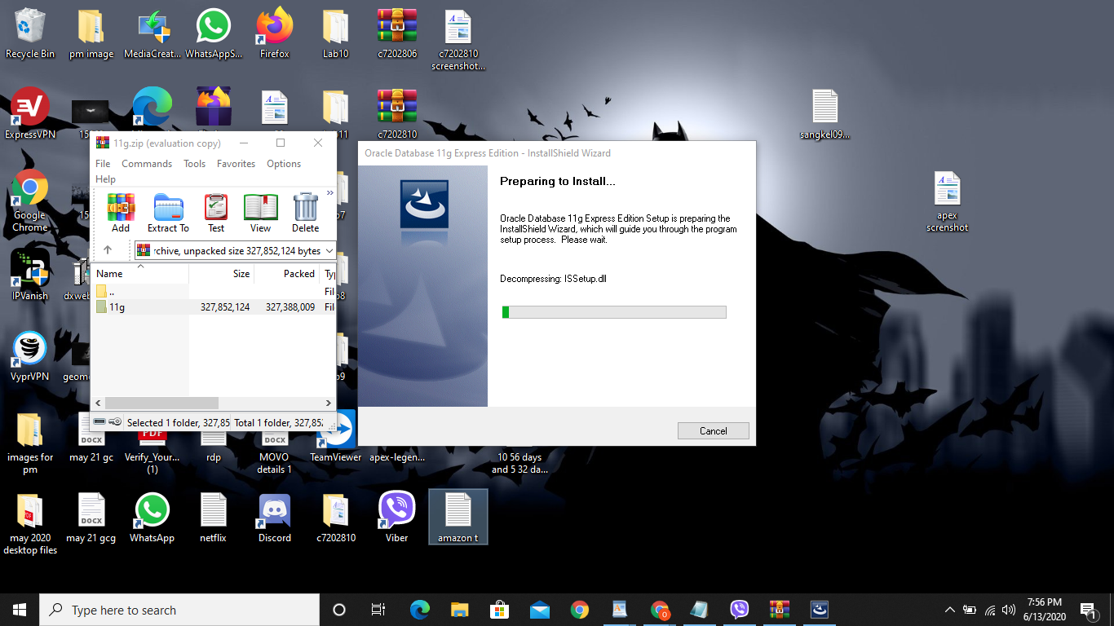

Step 2: Now click on Next

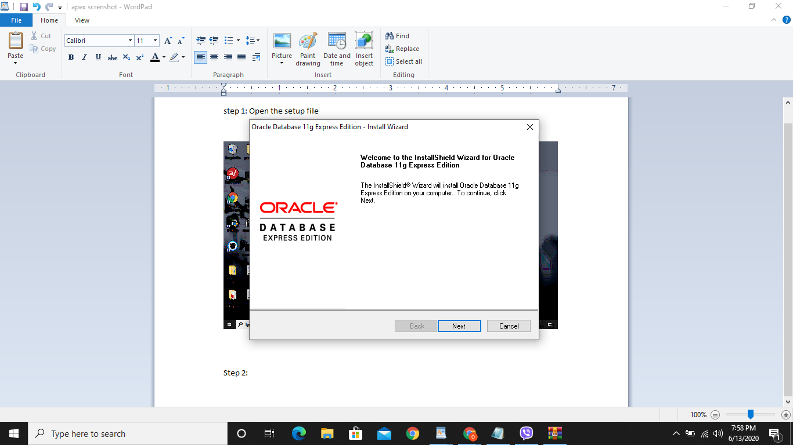

Step 3: Now choose I agree the agreement and click next,

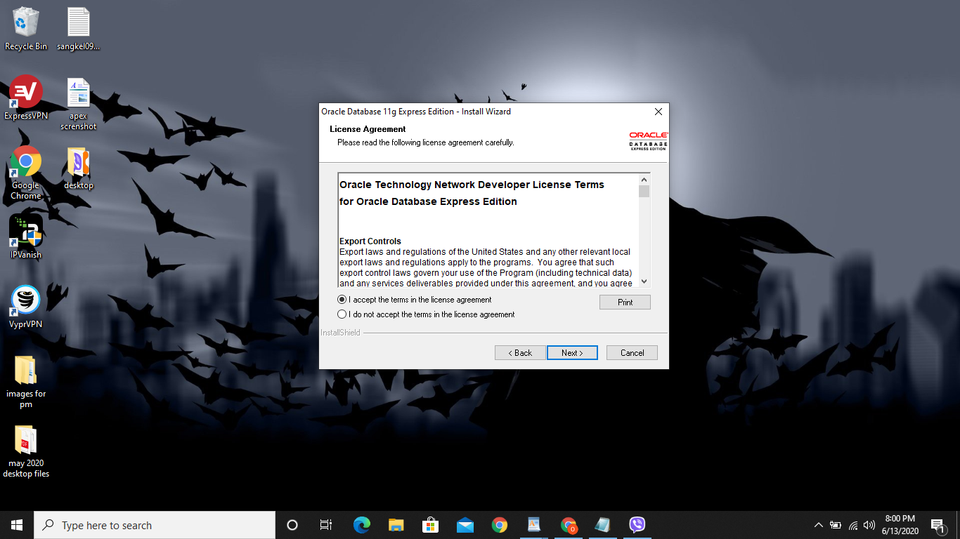

Step 4: Tick on Oracle edition and click Next

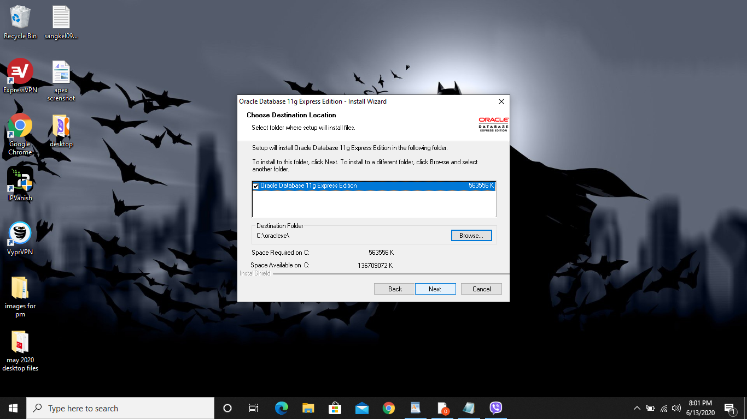

Step 5: Enter the strong password for security and click Next

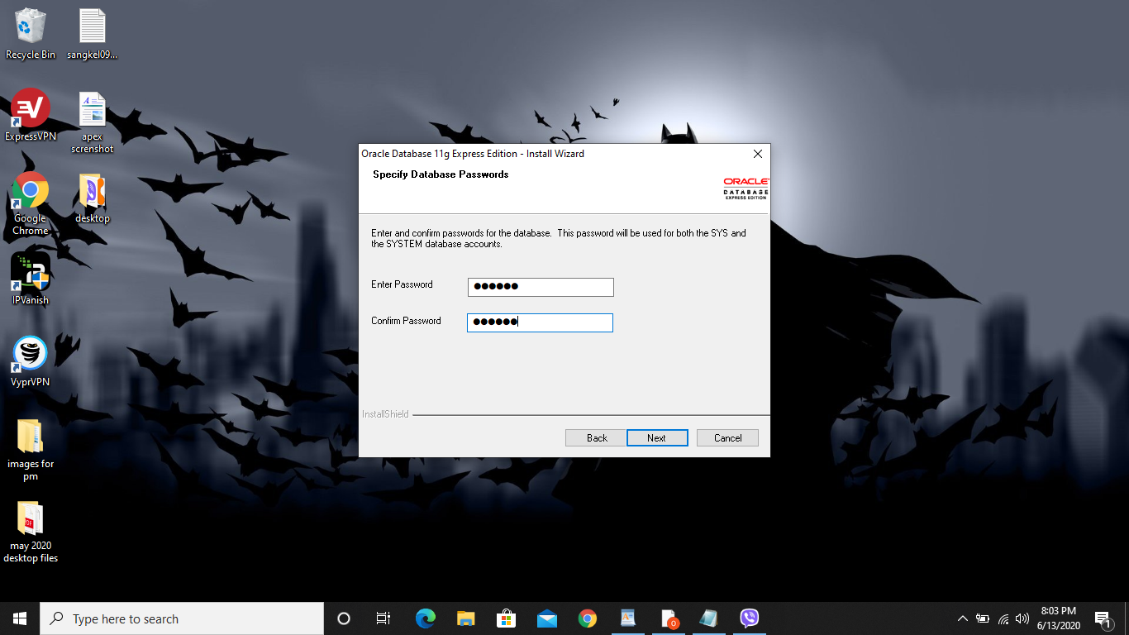

Step 6: Now click Install

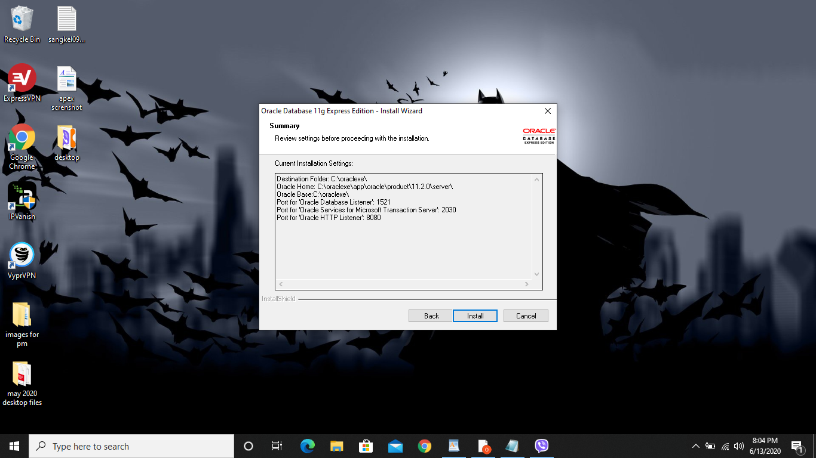

Step 7: Wait for a while until the installation process is complete:

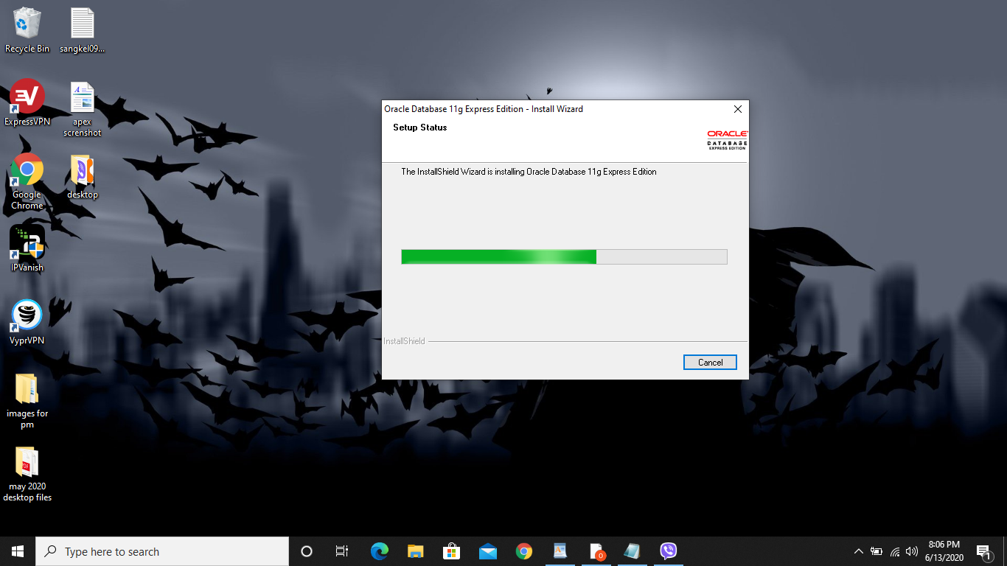

Step 8: open the link 127.0.0.1:8080/apex/f?p=4950, then this window will open, go to application express:

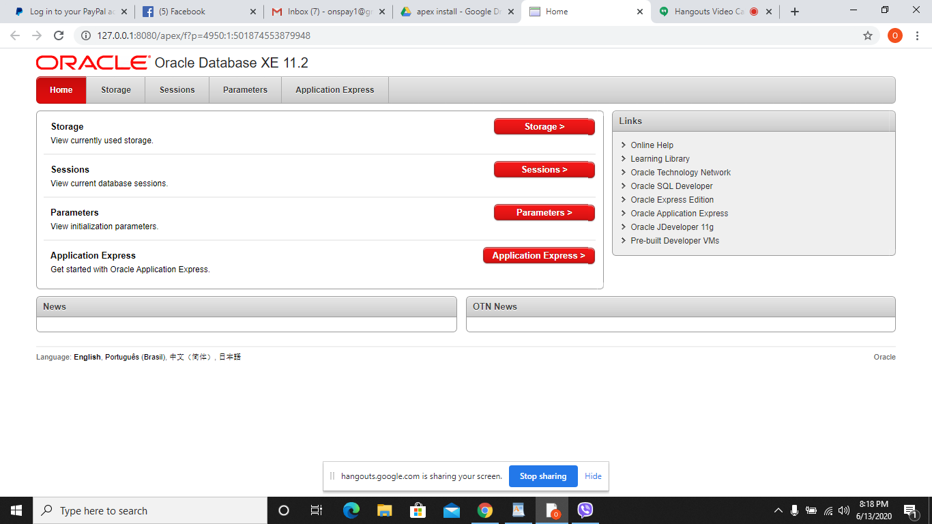

Step 9: Put your login details and click on login

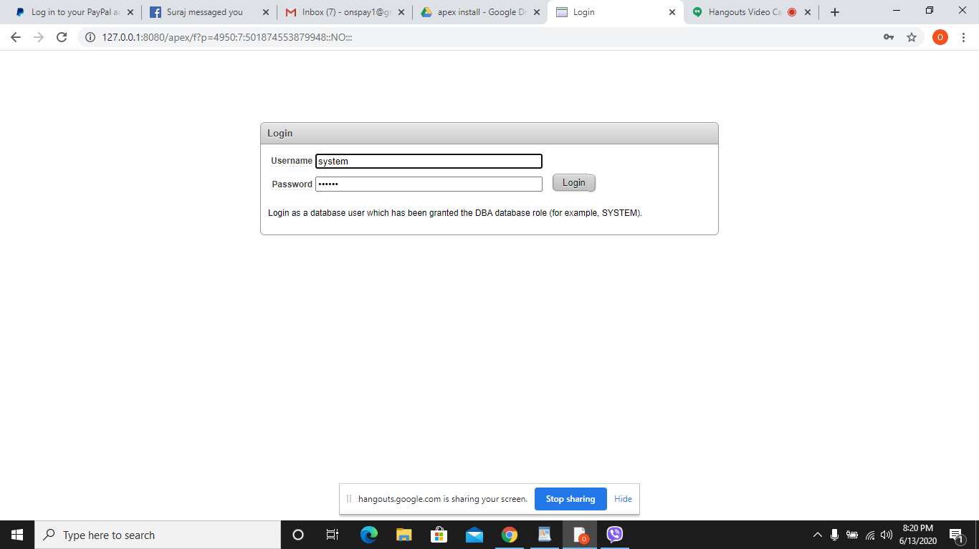

step 10: Click on Create workspace, with login details

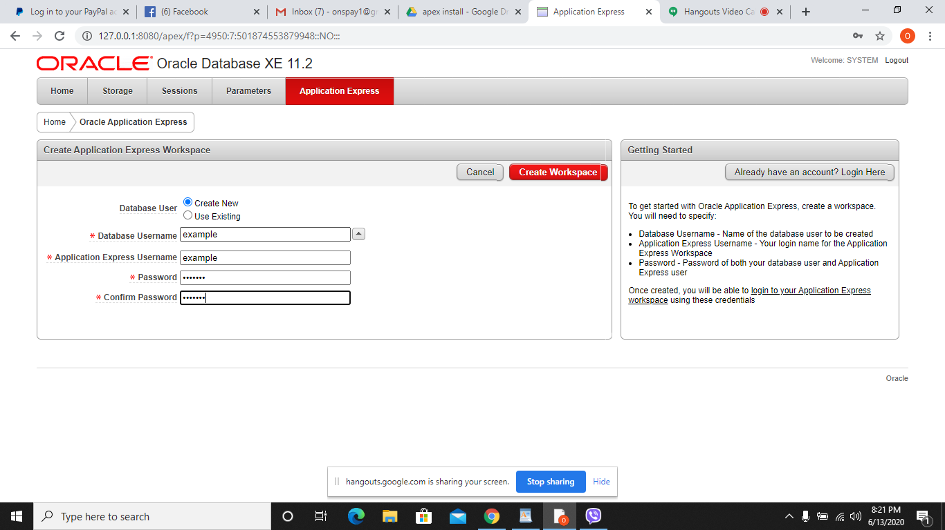

step 11: login on workspace

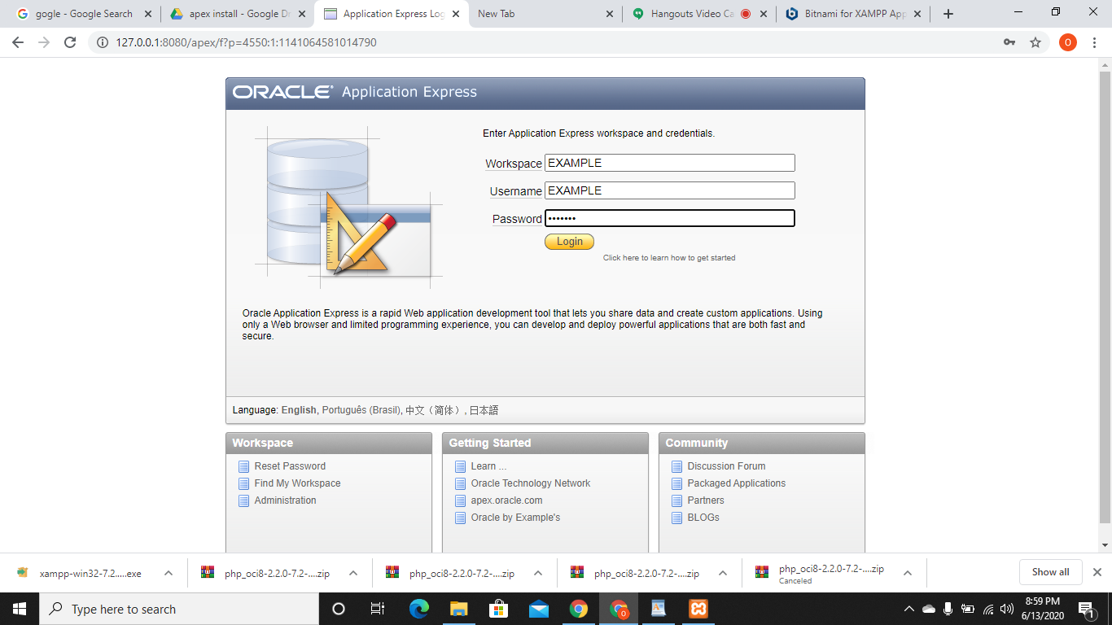

copy these two files:

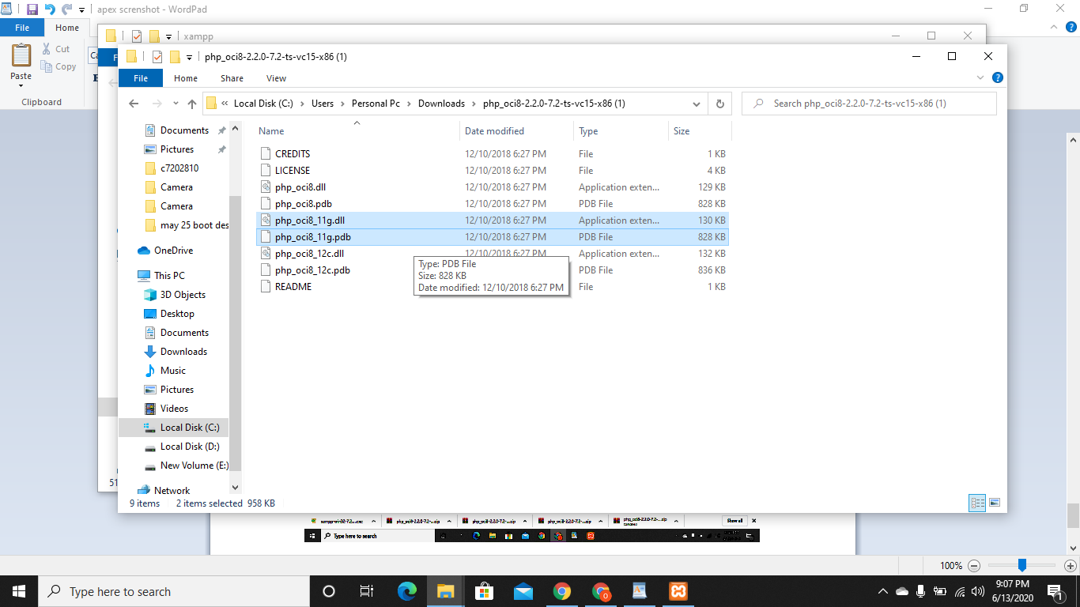

paste it here

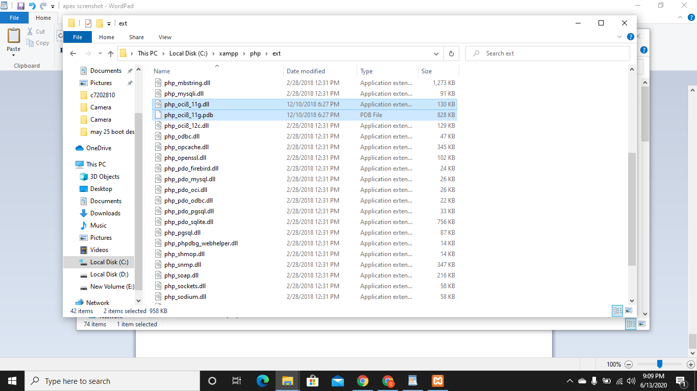

open php.ini

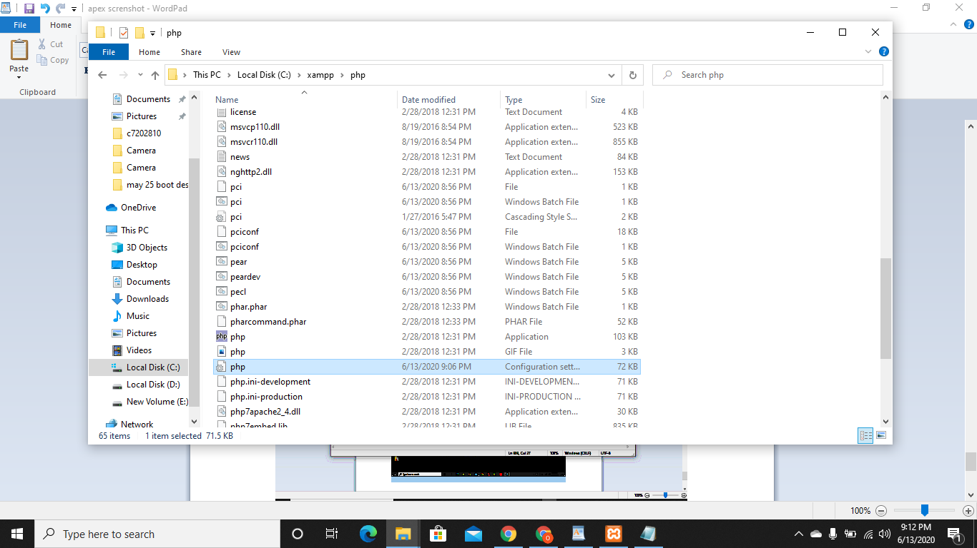

add this code(extension=php_oci8_11g.dll) to this file

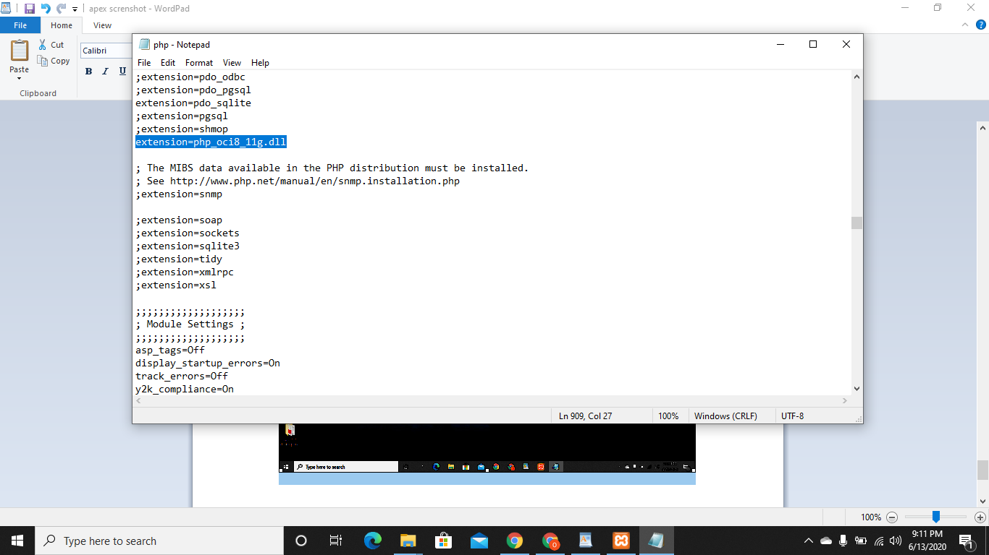

then add connect.php file to htdocs of xampp

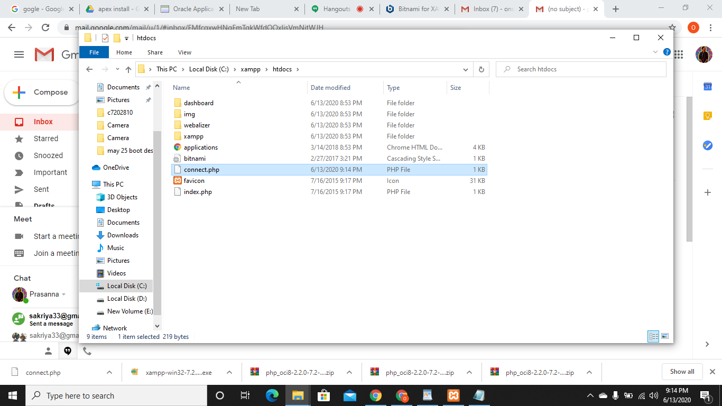

Add this code to connect.php

<?php

$conn = oci_connect('example', 'example', '//localhost/xe');

if (!$conn) {

$m = oci_error();

echo $m['message'], "\n";

exit; }else {

print "Connected to Oracle!";

}

?>

After all the process above, press windows + R and type cmd then run, cmd as administrator and make apex directory

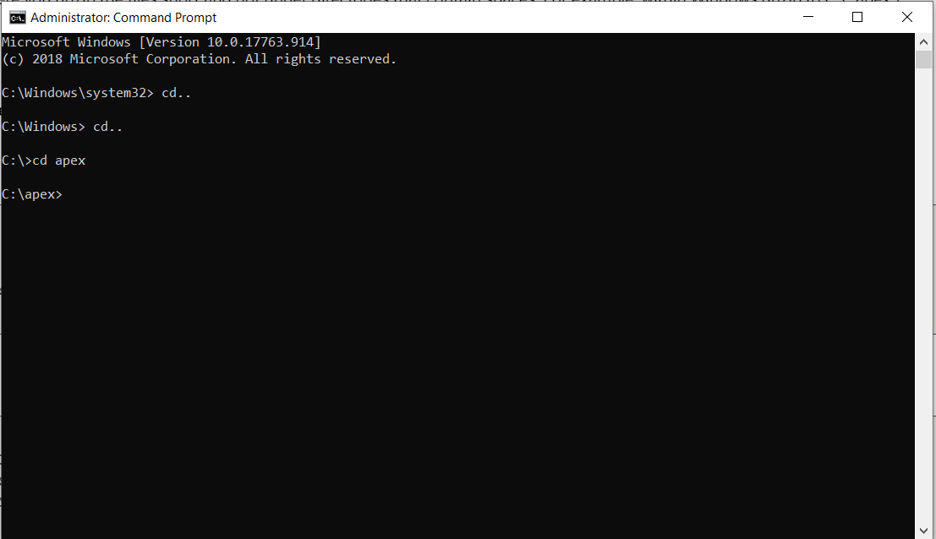

Then type Sqlplus / nolog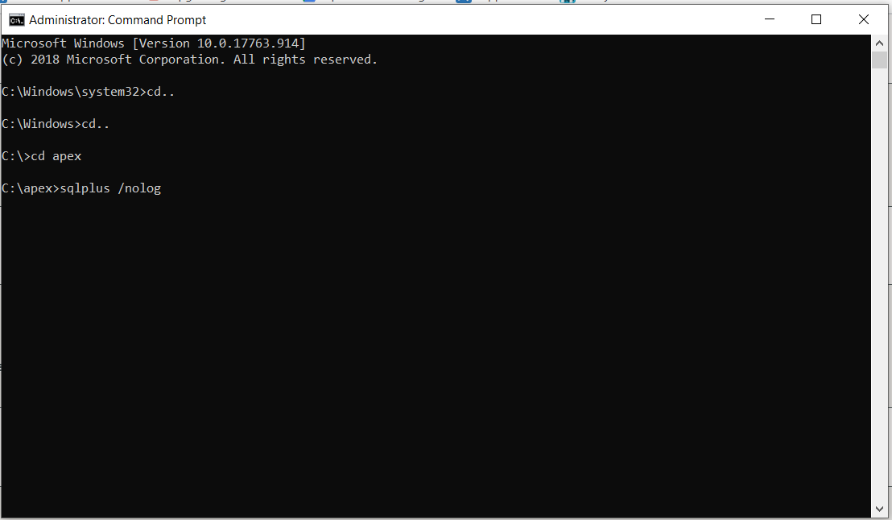

After that, type CONNECT SYS as SYSDBA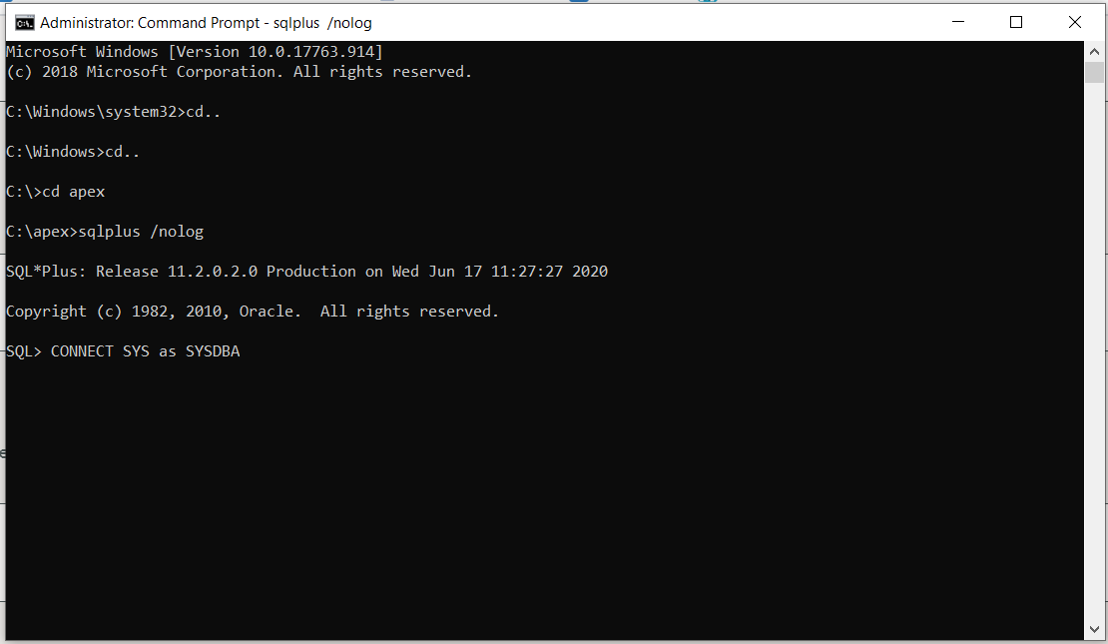

Type the System password set at the installation of the apex.

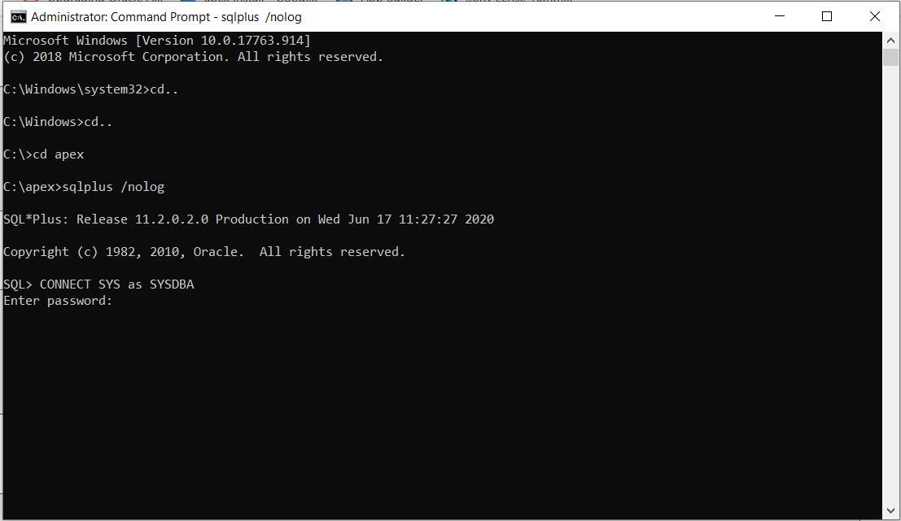

After getting connected, Install Application Express:

SQL> @apexins SYSAUX SYSAUX TEMP /i/

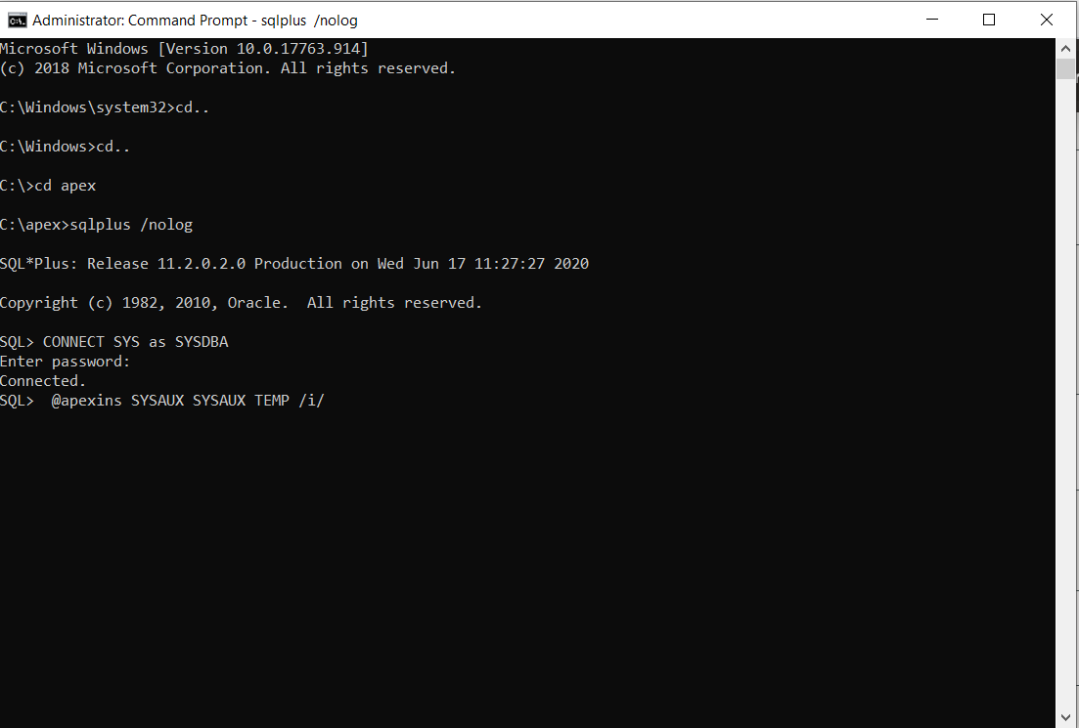

Then Log back into SQL*Plus (as above) and type this

SQL > @apex_epg_config.sql C:\

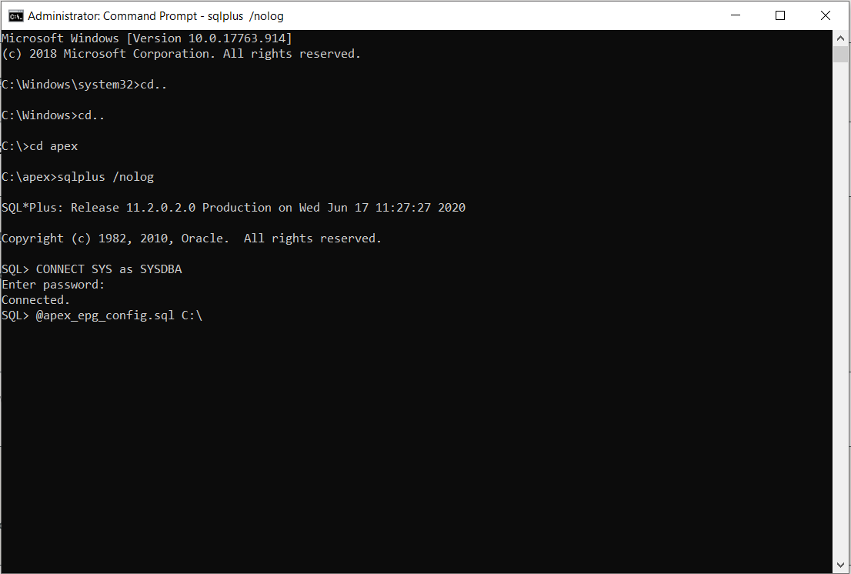

After that, Upgrade Application Express password by typing @apxchpwd: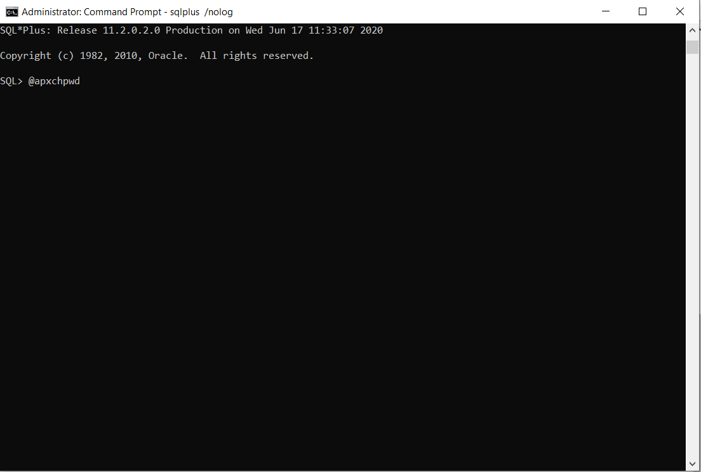

After this change the password and you are done.

